**Information:**

Interview conducted with Interviewee 3 (female; HE)

27 minutes

Language spoken: English

Automatic transcription done with Zoom Audio transcription, and checked by a coder.

**Follow-up to the survey on the use of machine translation in health contexts**

**Researcher:** Thank you again for accepting to participate in this interview. As you already know, this is a follow-up interview to the questionnaire on the use of machine translation in healthcare in the Netherlands. You replied to this questionnaire earlier this year. Let me start by reminding you that this interview is being recorded. The data collected will be anonymized and analyzed together with other participants’ data. The recording itself will never be published or shared, and it will be deleted as soon as it is transcribed and anonymized. You are free to request a copy of the transcription. In the interview itself, we will invite you to go over potential scenarios regarding the use of technology - specifically, machine translation like Google translate or any other translation system on your phone or device - in healthcare contexts, like when you receive an invitation letter to get vaccinated or when you go to the doctor, huisarts.  The goal is to understand how machine translation can be used and what are the main challenges or opportunities when using it. We aim to create free training for users of machine translation like yourself in order to better support communities in these situations. The scenarios that we will show you are fictitious. They are potential scenarios or stories. The focus is on what you think a person would do if they were in this situation. Discuss anything that comes to mind or that you would like to share. We just ask you not to share confidential information about yourself.  If at any point, during the interview, you feel uncomfortable and you want to pause the interview, please just let us know. We can rephrase the question or stop the interview altogether. You can leave at any point during this interview. Any questions or concerns?

**Participant:** No, I think everything is very clear.

**[STAGE 1 SLIDE 2]**

**Researcher:** I will start now by reading the first scenario that you can also see on the screen.“Two years ago, Maria moved to the Netherlands from Spain. It was right amid the pandemic, and she moved to take up a position at a new company in Rotterdam. Maria is a native speaker of Spanish, and she also speaks English. She has taken two Dutch courses online, so she understands and speaks rudimentary Dutch. For example, she can ask for a drink or have short conversations with neighbors, but not enough to feel fully comfortable speaking Dutch fluently in all situations. In 2021, she received a letter from the RIVM inviting him to get vaccinated against COVID-19. The letter is in Dutch.” What do you think about this case?

**Participant:** Um! Well, it's very familiar, because I would be in the same situation that Maria is, only that I don't speak or understand any Dutch despite having taken one course. Uhm, I think I've struggled with this myself. Um, I think that the Netherlands is considered to be a very international country, and with lots of expats, and you know, citizens from all other countries. Uh, and I think there should be at least some provision to have official documents sent in English, especially those to do with something as important as health. And the same goes for health insurance, for instance.

**Researcher:** What do you think Maria can do in this situation with the letter?

**Participant:** The options, the two that come to mind, uh, would be… the first one, use some device to translate into English like Google Translate, which you can do easily with your phone. I've got it on my phone, and you just click on the app and then on the camera, and you just hover the phone, and it translates instantly; it's very handy. Now, usually, the translations aren't that great. You can get the gist of it, but if it's something important like a vaccination letter, the second option that Maria or I could do was to ask a colleague, “Sorry. Could you translate this letter? Could you read, and then tell me exactly what it says?” Those are the two that come to mind, the easiest and perhaps the most effective ones.

**[STAGE 2 SLIDE 3]**

**Researcher: “**Because the letter mentioned COVID-19 and vaccinatie, and Maria had been waiting for more information on when and how she could get vaccinated, it was very important for him to understand the letter completely and thoroughly in all its detail. She tackles this by trying to read the letter top to bottom, sentence by sentence. The letter is hard to understand. She does not know many of the words used, and she feels increasingly nervous.” Why do you think Maria feels this way?

**Participant:** I guess, because again it's a letter to do with vaccination, with the pandemic as a situation which has been very straining and mentally stressful for all of us, she's really eager to get vaccinated. She would want to understand the letter as soon as possible so that she knows what the next steps to get vaccinated are. So, maybe that's why she feels also frustrated that she doesn't understand the language, frustrated with herself that she doesn't know the language, but also with the system that doesn't allow for an alternative on issues as important as this, maybe.

**Researcher:** Have you ever found yourself in a similar situation?

**Participant:** Um, yes. I guess whenever I get a letter. So, for instance, I had a screening for... I have the human papillomavirus. I had to go to the gynecologist. I had to go to the hospital here, and all the letters arrived in Dutch, and I didn't, really… I didn't understand anything other than, you know, the very basic words that are similar to Spanish or English. So I had to translate it first, and then ask a colleague to “Can you confirm that it says what I think it says?” I didn't really feel very nervous, but in terms of, like, worried about the content of the letter, I was a bit annoyed that I had to go through all this process to confirm that the content of the letter was what I thought it was. And also, maybe I mean, I don't know, if this is not really perhaps useful. But when I went to the appointment, the doctor spoke to me in English, but then there were other two doctors, and among the three of them, they were speaking Dutch about what they were seeing, and I never understood what they were saying, and I thought, I mean maybe it's for the better, because I didn't know what they were saying. But, anyway, that's not to do with machine translation.

**Researcher:** The doctors were discussing your condition in front of you, and you did not have access to the information.

**Researcher:** Yes! That was not nice.

**[STAGE 3 SLIDE 4]**

**Researcher: “**Maria decides to use Google Translate. She opens the app on her phone, and using the camera, she scans the letter. It is rather challenging.” How would you say her user experience with the app is? What kind of problems do you think she might face with this technology?

**Participant:** I think there are two levels of user experience. The first level is: It's a very handy tool which allows you to access the content, in this case of the letter, but very rudimentary. So you get a very basic idea of what the letter is saying that, on the one hand, is handy. But then, Instinctively, you feel that the language you're reading, or the translation that you're reading, does not sound particularly correct English, so you wonder whether it's actually being translated accurately or not. So, there are limitations. So it's a handy tool for a very basic level of translation, but I would always ask an actual human being who is fluent in both languages to translate it for me. I would not completely trust Google Translate at this stage.

**Researcher:** Have you ever found yourself in a similar situation?

**Participant:** Yes, multiple times.

**[STAGE 4 SLIDE 5]**

**Researcher: “**Maria is able to make an appointment for her vaccination. On the day of her appointment at the vaccination center, she goes to the counter, where she is asked in Dutch to present her ID and letter of invitation. She manages to understand this because the person on the counter makes a sign of the ID with her hand. Maria is nervous. Next, she is asked to fill in a health questionnaire in Dutch.” What would you recommend Maria to do next?

**Participant:** First, I would say to the person in the counter that I do not, I'm not confident communicating in Dutch. So, I would ask if there's a questionnaire in English. Assuming that there isn’t one, based on my experience so far, I would get my phone out and use Google and try and fill in the questionnaire with whatever translation Google gives me.

**[STAGE 5 SLIDES 6-8]**

**Researcher:** “Because she has some knowledge of Dutch, and the first questions in the form do not appear to be difficult, such as *Naam,* *Achternaam*, Maria tries to answer them in Dutch. On the second page, though, she reads three questions she does not understand. She does not understand questions 11, 12 and 13.”

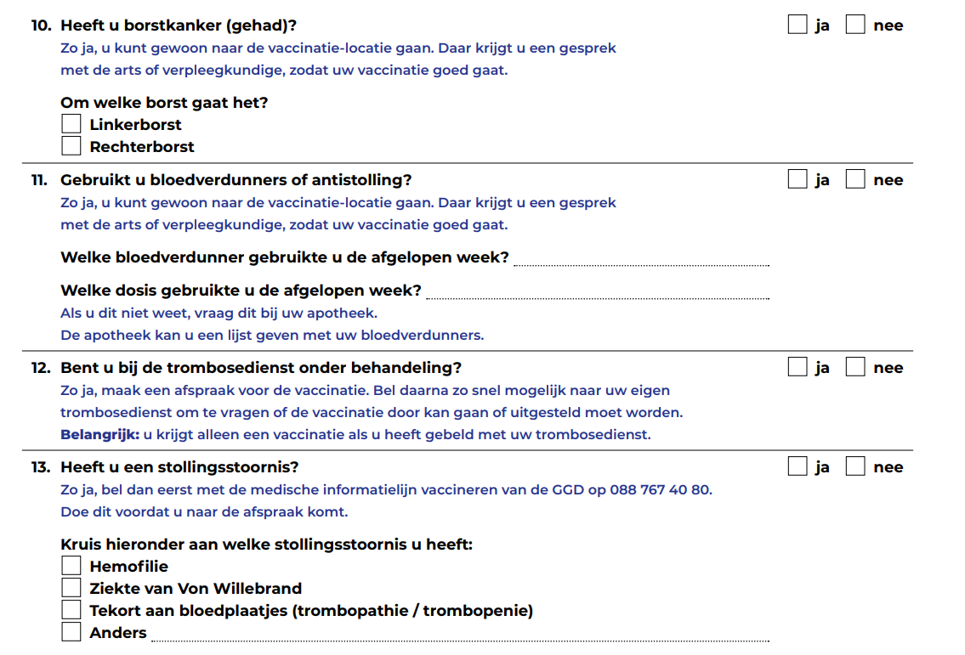

**Researcher:** What would you recommend Maria to do next?

**Participant:** I would recommend that she use the app.

**[STAGE 6 SLIDE 9]**

**Researcher:** “Maria asks for help from the young man behind the counter. She asks in Dutch if she can explain what is “bloedverdunners of antistolling”,  “trombosedienst onder behandeling”, and “stollingsstoornis” by pointing at the form with her finger. The young man looks surprised. She looks at the next counter, and it is empty. She looks behind, and everyone seems busy. She then tries to start a sentence a couple of times and finally says in English that these are diseases.”What would you recommend Maria to do next?

**Participant:** Well, I would, first ask the lady if she knows the name, the specific name of the diseases in English, and if not, if she is not able to help, then again, I would resort to Google Translate, and try and find the translation to these.

**Researcher:** Have you ever found yourself in a similar situation?

**Participant:** Yes, so I went to the pharmacy to get… I got a prescription from my GP, and I went to pick it up at the pharmacy because I had herpes, a massive herpes. I had never had that, but it was massive, covering a lot of my face. Basically, they gave me a prescription, and I went to pick it up at the pharmacy and I asked, “But do you know,…?” Because in my GP they didn't want to see me. So, they [the doctor] said, “Send us pictures of what happened, and we'll try…”. Well, no one ever told me what happened, I mean, and I assume it was herpes. So the lady said to me, “Oh, it's…” and then she said the name in Dutch. And I said, “Sorry, I don't understand Dutch. What is that?” And she said, “Oh, it's-it translates to white beard.” Okay, okay, I have never heard that. So then I googled “white beard”, and then obviously, nothing came up like, just you know, image of people with white beards.. Then I googled “white beard herpes” and then I saw the original word in Dutch, and then I entered that in Google, and through that I was able to find what I think the problem was. So I have to spend five, ten minutes, and going re-reverse translation to try and find out what was happening. So the lady gave me actually the literal translation in English, so from that to English, but obviously in my head that meant nothing. So then I had to go and do the research myself.

**[STAGE 7 SLIDE 10]**

**Researcher:** “Maria turns to her phone, opens the Google Translate app, and types the words she does not understand.”In your opinion, is Maria taking a risk by using Google Translate?

**Participant:** Partly yes, because I still believe that it's not fully trustworthy, but (pauses), but (pauses), yeah, I mean instead of Google-I mean, I would go to Google translate first and then normal Google. And just to the name of the disease to get confirmation. Yeah, I don't really know how Google translate really works. I don't know if you're doing the same basically twice, entering, you know, on Google Translate and then normal Google. I don't really understand how Google, but that's what I would do.

**[STAGE 8 SLIDE 11-15]**

**Researcher: “**Maria turns to her phone, opens the Google Translate app, and types the words she does not understand.”

We are going to use a scale for the following questions:

5 = to a very high degree

4 = to a high degree

3 = to a moderate degree

2 = to a low degree

1 = not at all

Is the scale clear?

**Participant:** Yes, so five is the best answer.

**Researcher:** What level of understanding do you think Maria has when using the app? Does Maria understand the text…

5 = to a very high degree

4 = to a high degree

3 = to a moderate degree

2 = to a low degree

1 = not at all

**Participant: (**reads the question). And this is the translated text. Um, Okay, I think (pauses), based on my experience. I think that on a literal level, you understand (pauses), but not on a specific level. So I would say on a very basic level five. You understand the meaning of the words Google is translating them. Then, if you put all the meanings of the words together in context, maybe the letter or the questionnaire does not make full sense. So I would say, on a very basic level five, because you get all the literal translations. But then three, if we're talking about the overall, meaning, I would say, very low. So, a three.

**Researcher:** What degree of risk of significant harm is Maria exposed to if using the app? Is Maria’s health at risk?

5 = to a very high degree

4 = to a high degree

3 = to a moderate degree

2 = to a low degree

1 = not at all

**Participant:** I would say three.

**Researcher:** What degree of trust should Maria have in these translations? Should Maria trust these translations?

5 = to a very high degree

4 = to a high degree

3 = to a moderate degree

2 = to a low degree

1 = not at all

**Participant:** Well, yeah, I would say between two. And three. Uh-huh. I would not-I mean, yeah, two or three. I don't know if I can pick one, but low to moderate.

**Researcher:** What degree of vulnerability do you think Maria has while using the app? Is Maria at risk of being vulnerable?

5 = to a very high degree

4 = to a high degree

3 = to a moderate degree

2 = to a low degree

1 = not at all

**Participant:** Five.

**Researcher:** Are there any other comments about this scenario or related scenarios you can think of?

**Participant:** So, on the one hand, I think because the Netherlands is a country where there's, the majority of the population speak English to moderate, or to very good degree, you can always resort to, you know, asking directly people about, you know, clarification. But when you- and again I've experienced this, when you're by yourself, you receive a letter, you're at home. I don't live with anyone, so I don't know anyone who speaks that when I'm at home, so I have to resort to the apps. But in this scenario, obviously, if she's in a vaccination center and the other people around… If the lady at the counter doesn't really understand or is not able to, I would perhaps go and approach, I don't know a nurse and ask, “Sorry, What does this mean? What is the translation?” Especially, perhaps, and perhaps I'm a bit biased here, but I would turn to slightly younger looking people, because younger people have better command of English, and perhaps they've even studied in English, or maybe they know the literal translation, and that-that could help. But that's only if you're in a physical space with all the people. But in my case, when I was alone at home and I received letters, all I could do was either use Google translate or just Google the words, and try and see and read different entries to try and understand what they were.

**[Training - follow-up questions – SLIDES 16-17]**

**Researcher:** Before we end the interview, we also wanted to ask you what sort of training on using these machine translation apps you would find helpful.

What type of information on machine translation would make your life easier when using these apps in health contexts?

For instance, do you feel you need more instructions on how to use the apps? Can you give us an example?

What about information about how to deal with the translations themselves? Do you have an example?

Would it be helpful to understand better the instances when machine translation is not advisable?

**Participant:** Well, in the case of Google translate, I think it's very um self explanatory? Yes. But in that case I don't think.. SoI would perhaps unless you use these apps often you don't really know that the translations they give you aren't really very, very good, as-as translations go. So I would perhaps add, like you know, when you open the app, like a pop-up message, saying that the translations must be held with, I don't know what the word then would be like. You know where that perhaps the translations aren’t perfect translations. And you know, we suggest, you ask a human being other than a computer for clarification, especially if it's something delicate.

**Researcher:** A warning? Would it be helpful to understand better the instances when machine translation is not advisable? When it’s advisable to use and when it’s not?

**Participant:** Yes, but I guess this would be, I mean, this would be an issue of may- maybe personal experience, when you've had a negative or a positive experience in what context. Uh, for health-related issues, I would have still at this stage very low confidence.

**Researcher:** How would you like access to more information to make using these apps easier?

For instance, would you prefer to have short videos on a website or YouTube, step-by-step guides, or infographics?

Would you prefer to be offered free in-person training? And where?

If there was a website with infographics and videos explaining how to use these apps better, would you find that helpful?

**Participant:** I would have Youtube video with, like information bullet points very clear (makes gesture with hand). All the screenshots on the app, so you can see yes, directly, with I don't know a link to uh click on-on. Or a website with the video in there.

**[Closing]**

**Researcher:** Thank you for participating in our research. Our times of analysis and publication are long, but feel free to write to us to obtain the results of this research. Otherwise, we will contact you with the results in due time.